- Download the ExpressTime Kiosk app from the iPad App Store.
- Open the ExpressTime Kiosk app.

Building setup
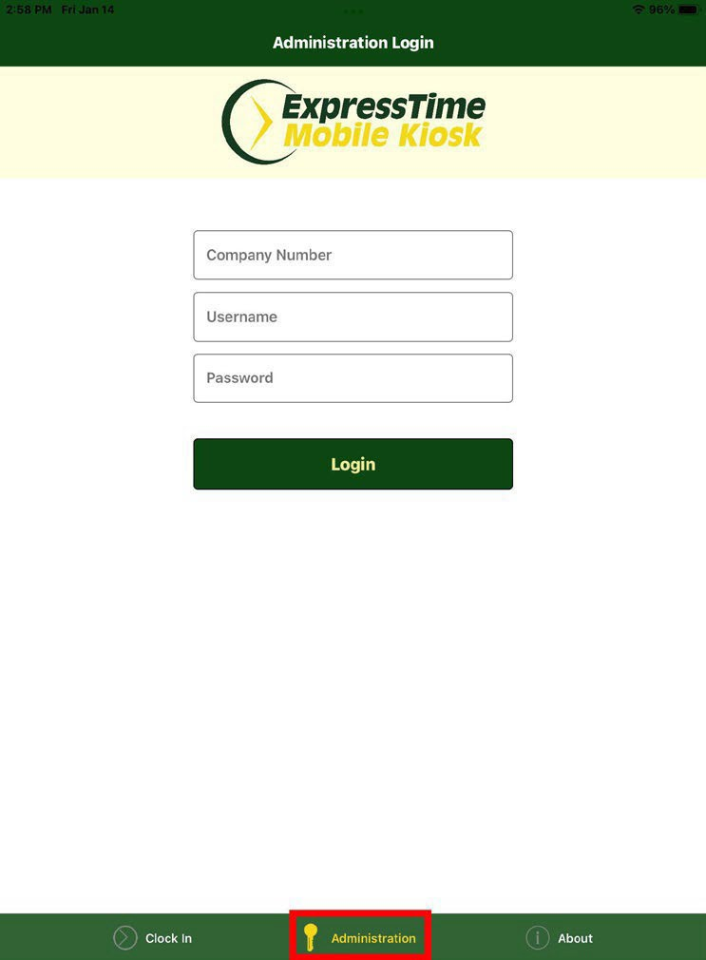3a.

Company ID: (your company ID)
Username: AppMgr
Password: M@gic!

3b.

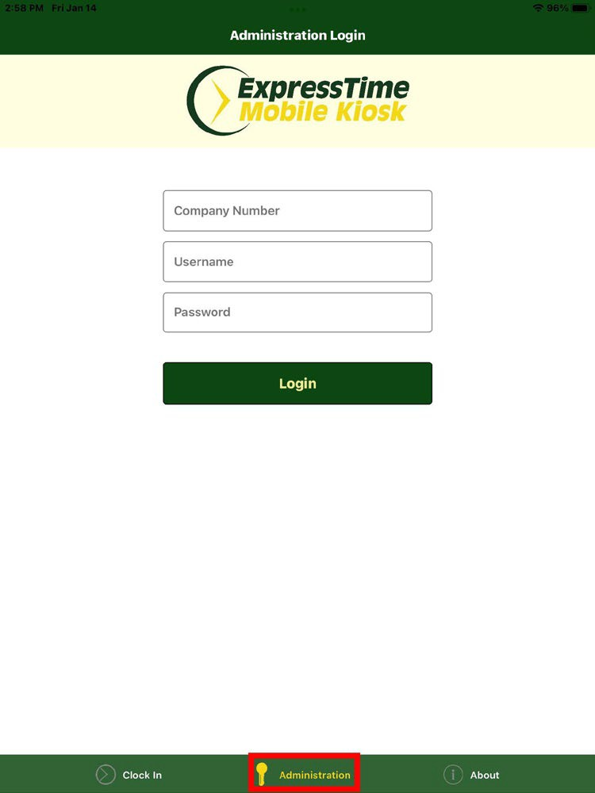-Enter your company ID.

-Enter the building number the kiosk will be used in.

-Enter the time zone of the building using the format below:
- 0.0 central time
- 1.0 eastern time
- -1.0 mountain
- -2.0 pacific

-Use Daylight Savings Time: Yes

-Click the Save Building Settings

ExpressTime Kiosk is now configured correctly and ready for use.

How to Set iPad to Kiosk Mode

- Open Settings
- Tap Accessibility
- Toggle Guided Access on
- (Optional) -Tap Passcode Settings to setup a passcode for Guided Access.
- Open the ExpressTime Kiosk app
- Triple click the Home button or the side button on the 2018 iPad Pro while on the employee clock in screen to activate the iPad’s kiosk mode. Triple click again to deactivate kiosk mode.

